Contenido

Código para hacer triggers: 2

Código 1: 2

Código 2: 2

Código 3: 3

Código 4: 3

Código 5: 4

Código 6: 4

Código 7: 5

Código 8: 5

Código 9: 6

Código 10: 6

Imágenes de las tablas en MySQL MySQL Workbench: 7

Imagen 1: 7

Imagen2: 8

Tablas1: 9

Tabla2: 9

Diagrama de base de datos : 10

Diagrama lógico : 11

## Código para hacer triggers:

### Código 1:

DELIMITER $$

USE `station_23`$$

CREATE DEFINER = CURRENT_USER TRIGGER `station_23`.`T15I_Vehiculo` BEFORE INSERT ON `vehiculo` FOR EACH ROW

BEGIN

set new.UsuCrea = USER();

set new.FecCrea = NOW();

set new.UsuModif = USER();

set new.FecModif = NOW();

END$$

DELIMITER ;

### Código 2:

DELIMITER $$

USE `station_23`$$

CREATE DEFINER = CURRENT_USER TRIGGER `station_23`.`T16U_Vehiculo` BEFORE UPDATE ON `vehiculo` FOR EACH ROW

BEGIN

set new.UsuModif = USER();

set new.FecModif = NOW();

END$$

DELIMITER ;

### Código 3:

DELIMITER $$

USE `station_23`$$

CREATE DEFINER = CURRENT_USER TRIGGER `station_23`.`T01I_Administrador` BEFORE INSERT ON `administrador` FOR EACH ROW

BEGIN

set new.UsuCrea = USER();

set new.FecCrea = NOW();

set new.UsuModif = USER();

set new.FecModif = NOW();

END$$

DELIMITER ;

### Código 4:

DELIMITER $$

USE `station_23`$$

CREATE DEFINER = CURRENT_USER TRIGGER `station_23`.`T02U_Administrador` BEFORE UPDATE ON `administrador` FOR EACH ROW

BEGIN

set new.UsuModif = USER();

set new.FecModif = NOW();

END$$

DELIMITER ;

### Código 5:

DELIMITER $$

USE `station_23`$$

CREATE DEFINER = CURRENT_USER TRIGGER `station_23`.`T03I_Cupon` BEFORE INSERT ON `cupon` FOR EACH ROW

BEGIN

set new.UsuCrea = USER();

set new.FecCrea = NOW();

set new.UsuModif = USER();

set new.FecModif = NOW();

END$$

DELIMITER ;

### Código 6:

DELIMITER $$

USE `station_23`$$

CREATE DEFINER = CURRENT_USER TRIGGER `station_23`.`T04U_Cupon` BEFORE UPDATE ON `cupon` FOR EACH ROW

BEGIN

set new.UsuModif = USER();

set new.FecModif = NOW();

END$$

DELIMITER ;

### Código 7:

DELIMITER $$

USE `station_23`$$

CREATE DEFINER = CURRENT_USER TRIGGER `station_23`.`T05I_Pago` BEFORE INSERT ON `pago` FOR EACH ROW

BEGIN

set new.UsuCrea = USER();

set new.FecCrea = NOW();

set new.UsuModif = USER();

set new.FecModif = NOW();

END$$

DELIMITER ;

### Código 8:

DELIMITER $$

USE `station_23`$$

CREATE DEFINER = CURRENT_USER TRIGGER `station_23`.`T06U_Pago` BEFORE UPDATE ON `pago` FOR EACH ROW

BEGIN

set new.UsuModif = USER();

set new.FecModif = NOW();

END$$

DELIMITER ;

### Código 9:

DELIMITER $$

USE `station_23`$$

CREATE DEFINER = CURRENT_USER TRIGGER `station_23`.`T09I_Tarifario` BEFORE INSERT ON `tarifario` FOR EACH ROW

BEGIN

set new.UsuCrea = USER();

set new.FecCrea = NOW();

set new.UsuModif = USER();

set new.FecModif = NOW();

END$$

DELIMITER ;

### Código 10:

DELIMITER $$

USE `station_23`$$

CREATE DEFINER = CURRENT_USER TRIGGER `station_23`.`T10U_Tarifario` BEFORE UPDATE ON `tarifario` FOR EACH ROW

BEGIN

set new.UsuModif = USER();

set new.FecModif = NOW();

END$$

DELIMITER ;

## Imágenes de las tablas en MySQL MySQL Workbench:

### Imagen 1:

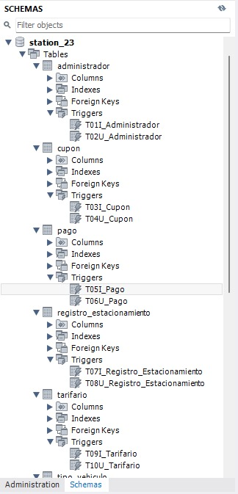

### Imagen2:

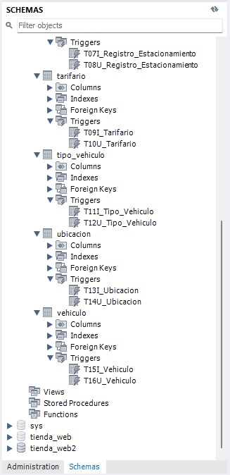

### Tablas1:

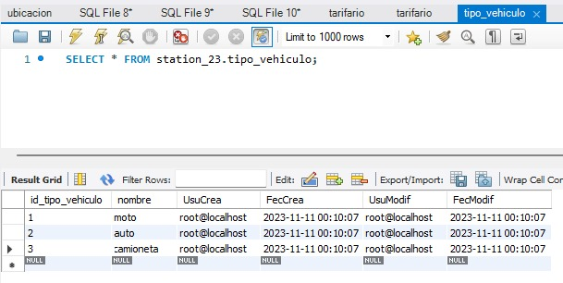

### Tabla2:

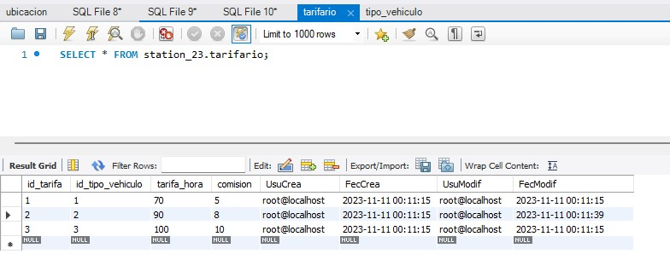

# Diagrama de base de datos :

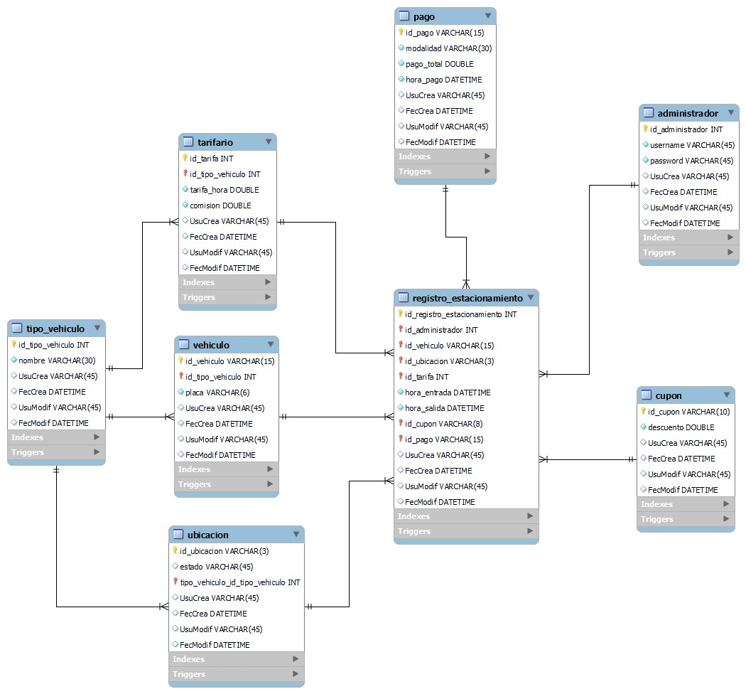

# Diagrama lógico :

